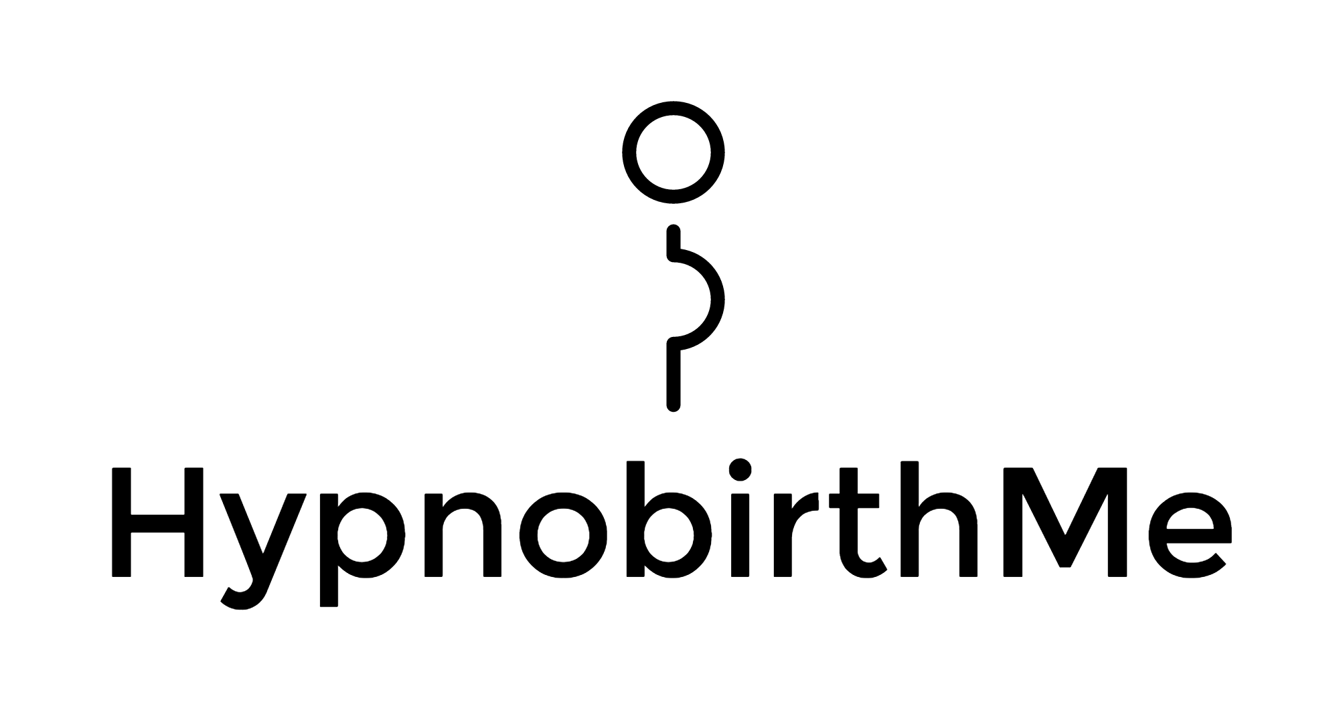

BABY BEING BORN

CALM AND QUIET PLEASE

Thank you

